**Excel Assignment – 16**

1. **What is a Macro? How is it useful in excel or in your daily work?**

A macro is **a set of instructions used to execute repetitive tasks**. You can record a set of commands and then play them back with one or two keystrokes. That means that you can save A LOT of time when doing routine and repetitive tasks.

1. **What is VBA? Write its full form and briefly explain why VBA is used in excel?**

**Visual Basic for Applications** is a computer programming language developed and owned by Microsoft. With VBA you can create macros to automate repetitive word- and data-processing functions, and generate custom forms, graphs, and reports. VBA functions within MS Office applications; it is not a stand-alone product.

1. **How do you record a macro? Write detailed steps to create a macro to automatically make the following table in bold and to create borders for it in excel.**
2. On the **Developer** tab, in the **Code** group, click **Record Macro**.

-OR-

Press **Alt**+**T**+**M**+**R** .

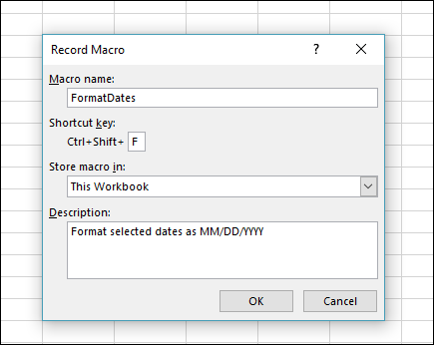

1. In the **Macro name** box, enter a name for the macro. Make the name as descriptive as possible so you can quickly find it if you create more than one macro.
2. To assign a keyboard shortcut to run the macro, in the **Shortcut key** box, type any letter (both uppercase or lowercase will work) that you want to use. It is best to use **Ctrl** + **Shift** (uppercase) key combinations, because the macro shortcut key will override any equivalent default Excel shortcut key while the workbook that contains the macro is open. For instance, if you use **Ctrl+Z** (Undo), you will lose the ability to Undo in that Excel instance.
3. In the **Store macro in** list, select where you want to store the macro.

In general, you’ll save your macro in the **This Workbook**location, but if you want a macro to be available whenever you use Excel, select [Personal Macro Workbook](https://support.microsoft.com/en-us/office/copy-your-macros-to-a-personal-macro-workbook-aa439b90-f836-4381-97f0-6e4c3f5ee566) . When you select **Personal Macro Workbook**, Excel creates a hidden personal macro workbook (Personal.xlsb) if it does not already exist, and saves the macro in this workbook.

1. In the **Description** box, optionally type a brief description of what the macro does.

Although the description field is optional, it is recommended you enter one. Also, try to enter a meaningful description with any information that may be useful to you or other users who will be running the macro. If you create a lot of macros, the description can help you quickly identify which macro does what, otherwise you might have to guess.

1. Click **OK** to start recording.
2. Perform the actions that you want to record.
3. On the **Developer** tab, in the **Code** group, click **Stop Recording** Button image.

-OR-

Press **Alt**+**T**+**M**+**R** .

1. What do you mean when we say VBA Editor?

Visual Basic Editor is **an application (a separate one) in which you can write and save all the VBA codes**. In simple words, it's a code editor for Excel in which you can write all the macros and store them. Even though it is a separate application (VB Editor) you can only use it with Excel.

1. Briefly describe the interface of a VBA editor? What is properties window? And what is watch window? How do you display these windows?

**To navigate the Properties window**

1. From the **View** menu of the Visual Basic Editor, choose Properties window (F4).
2. Select the object whose properties you want to display. You can either use the mouse to select the object or use the **Project Explorer** to choose from a list.
3. Click the **Alphabetic** tab to display properties in alphabetic order, or choose the **Categorized** tab to display object properties by category.

**To change a property's value**

1. Select the property in the left column.
2. Change the property's value in the right column.
3. What is an immediate Window and what is it used for?

Use the Immediate window **to debug and evaluate expressions, execute statements, and print variable values**. The Immediate window evaluates expressions by building and using the currently selected project.